**A1**. Demonstrate and Create project in local and remote repository using GitBash and GitHub and apply  init, status, log, add, commit, push, config, clone and reset commands on repository.

Git **init** command:

Description: The “git init” command initializes a new Git repository in the current directory

Installation of Repository

Syntax : git int [Repository name]

Example : git int

Git **status** command:

Description

Show the working tree Status

Syntax :git status

Example :git status

Git **log** command:

Description

Shows the commit history for the current branch.

Syntax :git log

Example :git log

Git **add** command:

Description

Stages changes in the working directory for the next commit.

Syntax :git add [file(s)]

Example :git add README.md

Git **commit** command:

Description

Records changes to the repository with a message.

Syntax :git commit –m “commit message”

Example :git commit –m “initial commit”

Git **push** command:

Description

Uploads local commits to a remote repository.

Syntax :git push [remote-name] [branch-name]

Example :git push origin master

Git **config** command:

Description

Sets Git configuration values such as user name and email.

Syntax :git config --global [key] [value]

Example : git config --list

Git **clone** command:

Description

Creates a copy of a remote repository on your local machine.

Syntax :git clone [repository-url]

Example :git clone https://github.com/username/projectname.git

Git **Reset** command:

Description

Resets the current HEAD to a specified state, optionally modifying the staging area.

Syntax :git reset [commit]

Example :git reset HEAD~1

**Git user configuration details**

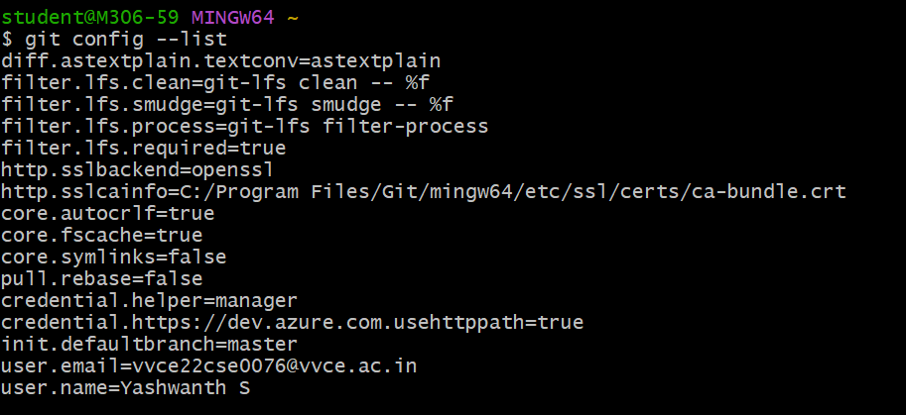

|  |  |  |  |  |
| --- | --- | --- | --- | --- |
| **Configuration** | **Execution** | **Viva** | **Total** | **Verified By** |
|  |  |  |  |  |